FAKE NEWS DETECTION USING DEEP LEARNING AND TRADITIONAL MACHINE LEARNING MODELS

**Author:** Sarvagya

**Deptt:** Computer Science and Engineering

**College:** Punjab Engineering College, Chandigarh

**Email:**  [sarvagya.bt22cseds@pec.edu.in](mailto:sarvagya.bt22cseds@pec.edu.in)

**City:** Jammu, Jammu & Kashmir

**Country:** INDIA

**ORCID:** 0009-0000-1181-127X

# **TABLE OF CONTENTS**

LIST OF FIGURES 3

CHAPTER 01: ABSTRACT 4

CHAPTER 02: INTRODUCTION 5

2.1 What is Fake News 5

2.2 Why Detect Fake News 5

2.3 Role of AI in Misinformation Detection 6

2.4 Objective of the Project 6

CHAPTER 03: INDUSTRY 7

3.1 Relevance in Modern Tech Industry 7

3.2 Industry Applications of Fake News Detection 7

3.3 Societal Impact 8

CHAPTER 04: REVIEW OF LITERATURE 9

4.1 Previous Work Using ML 9

4.2 Deep Learning in NLP 9

4.3 Gaps in Existing Systems 10

CHAPTER 05: PROJECT WORK 11

5.1 Objective of the Project 11

5.2 Project Motivation 11

5.3 Introduction to the Solution 12

5.4 Overview of the Dataset 12

5.5 Preprocessing Techniques 13

5.6 ML Models Used 14

5.7 DL Models Used 17

5.8 Model Evaluation Metrics 19

5.9 Final Model Pipeline 20

CHAPTER 06: TOOLS AND TECHNOLOGIES 21

6.1 Tools Used 21

6.2 Libraries and Frameworks Used 22

CHAPTER 07: CONCLUSION AND FUTURE SCOPE 23

7.1 Conclusion 23

7.2 Future Scope 24

CHAPTER 08: DIFFICULTIES FACED 25

CHAPTER 09: DECLARATIONS 26

CHAPTER 10: REFERENCES 28

## **List of Figures**

1. Sectors affected by Fake News.............................................................................................. 8
2. Detection of Fake News using AI........................................................................................... 10
3. Overview of Dataset.............................................................................................................. 13
4. Naïve Bayes Model......................................................................................................................... 14
5. Decision Tree Model................................................................................................................... 15
6. Random Forest ............................................................................................................................. 16
7. Logistic Regression....................................................................................................................... 17
8. RNN Model building and Accuracy........................................................................................ 18
9. BiLSTM Model building and Accuracy.................................................................................. 19
10. Model Comparison Across Evaluation Metrics..………………………………………....... 20
11. Libraries And Frameworks Used............................................................................................. 23
12. CNN-Autoencoder Based Framework for Advanced Fake News Detection………. 24

## **List of Abbreviations used**

1. AI: Artificial Intelligence
2. API: Application Programming Interface
3. BiLSTM: Bidirectional Long Short-Term Memory
4. BoW: Bag of Words
5. UI: User Interface
6. RNN: Recurrent Neural Network
7. TF-IDF: Term Frequency – Inverse Document Frequency
8. XAI: Explainable Artificial Intelligence
9. NLTK: Natural Language Toolkit

# **CHAPTER 01: ABSTRACT**

**Purpose:**

The objective of this project, titled *Fake News Detection*, is to address the critical issue of misinformation propagation in digital media. With the exponential growth of online news consumption and social sharing, detecting fabricated news content has become essential to uphold the integrity and reliability of information presented to the public.

**Methods:**

A hybrid classification approach was adopted, integrating both traditional machine learning models—such as Naive Bayes, Decision Tree, Random Forest, and Logistic Regression—and deep learning architectures including Recurrent Neural Networks (RNN) and Bidirectional Long Short-Term Memory (BiLSTM). The dataset comprised merged real and fake news articles. Preprocessing involved tokenization, stopword removal, and feature representation using TF-IDF and token sequences. Each model was evaluated using accuracy, precision, recall, and F1-score, and real-time prediction capabilities were added through a text-based input interface.

**Results:**

Among all models tested, the BiLSTM architecture achieved the highest classification accuracy and demonstrated superior contextual understanding. It was followed by Random Forest and Passive Aggressive Classifier. These outcomes confirm the advantage of deep learning methods in complex natural language classification tasks such as fake news detection.

**Conclusion:**

This work demonstrates a full development pipeline for an intelligent fake news classification system. The findings underscore the potential of advanced neural models for high-accuracy detection. Future work may involve deploying transformer-based models and extending the system for multilingual or cross-platform fake news identification.

# CHAPTER 02: INTRODUCTION

In today’s fast-paced digital age, the internet has become the primary source of information for billions of people. While this unprecedented connectivity has brought numerous benefits, it has also given rise to one of the most pressing challenges of the modern era — the widespread dissemination of **fake news**

As online content becomes easier to create and share, especially through social media platforms, distinguishing between real and fabricated information is increasingly difficult — even for seasoned readers. Manual verification of content is time-consuming and cannot scale to the vast volume of news generated daily. This necessitates the development of **automated fake news detection systems**, powered by advancements in **machine learning** and **deep learning**.

## **2.1 What is Fake News?**

Fake news refers to false or misleading information presented in the form of legitimate journalism, often with the intention to deceive or manipulate public perception. It mimics the appearance of credible news sources, using headlines, images, and formats similar to authentic articles, making it difficult to distinguish without further verification.

Unlike satire or opinion-based content, fake news is designed to appear factual. It often exploits emotionally charged topics such as politics, religion, or health to increase virality and engagement. With the rise of social media platforms, such content can spread rapidly to large audiences, amplifying its negative effects. We have recently seen a very good example of how fake news spread during recent INDO-PAK conflict and how dangerous it could be.

The core challenge In detecting fake news lies In Its linguistic subtlety — it may not contain outright lies but rather manipulated truths, selective facts, or misleading headlines. This makes **automated fake news detection a complex yet crucial problem** in the current digital landscape.

## **2.2 Why Detect Fake News?**

Detecting fake news is not merely a technical challenge but a societal necessity. The unchecked spread of misinformation can have severe consequences across multiple domains:

* **Political Manipulation**: Fake news has been weaponized to sway public opinion during elections, spread propaganda, and damage reputations of political figures or parties.
* **Social Polarization:** Fake news often exploits sensitive topics like religion, race, and nationalism, deepening divisions in society and sometimes inciting violence.
* **Economic Consequences**: False financial news can cause abrupt stock market movements or impact consumer trust in brands and companies and many more.

These risks highlight the urgent need for scalable, reliable, and intelligent systems capable of automatically identifying and flagging fake content.

## **2.3 Role of AI in Misinformation Detection**

Artificial Intelligence (AI), particularly **Natural Language Processing (NLP)** and **Deep Learning**, has emerged as a transformative solution to the fake news problem. These technologies allow systems to analyze text at a granular level — not just based on keywords, but by understanding context, sentiment, writing patterns, and even subtle linguistic cues.

Machine learning models can be trained on large labeled datasets to detect patterns that distinguish fake news from real news. For example:

* **Traditional ML models** like Naive Bayes or Logistic Regression use vectorized representations (like TF-IDF) of text to learn statistical relationships.
* **Deep Learning models** like RNNs and BiLSTMs can capture sequential dependencies, word order, and long-range context that simpler models often overlook.

AI systems are not only faster and more scalable than manual fact-checking, but they also evolve as they are trained on more diverse and larger datasets.

## **2.4 Objective of the Project**

The core objective of this project is to **design and implement a robust fake news detection pipeline** capable of accurately classifying news content as fake or real. The project explores and compares multiple algorithms across two main paradigms:

* **Traditional Machine Learning**: Includes Naive Bayes, Decision Trees, Random Forest, and Logistic Regression models trained on TF-IDF features.
* **Deep Learning**: Includes Recurrent Neural Networks (RNNs) and Bidirectional Long Short-Term Memory Networks (BiLSTMs), trained on tokenized and padded sequences.

Key goals include:

* Implementing effective text preprocessing techniques.
* Comparing the performance of different models using accuracy, precision, recall, and F1-score.
* Developing a real-time prediction module that takes news content as input and returns a classification result.

# **CHAPTER 03: INDUSTRY**

## **3.1 Relevance in Modern Tech Industry**

In an era where **digital credibility is currency**, fake news detection has emerged as a crucial component in the tech industry. Leading platforms like **Facebook**, **Twitter**, **YouTube**, and **Google News** are actively investing in AI-based systems to monitor, detect, and curb the spread of misinformation.

As misinformation tactics evolve, the tech industry must continuously advance its detection strategies to maintain public trust.

## **3.2 Industry Applications of Fake News Detection**

Fake news detection systems are no longer theoretical—they're being integrated into real-world applications across sectors:

* **Social Media Platforms**: Facebook and Twitter use AI-based content filtering systems to detect and label potentially false information. Users are often warned or redirected to verified sources.
* **News Aggregators**: Google News and Microsoft News employ fake news detection models to curate content from trusted publishers and demote potentially misleading articles in rankings.
* **Digital Advertising**: Advertisers use fake news classifiers to prevent their ads from appearing on unreliable or controversial websites, preserving brand safety.
* **Fact-Checking Organizations**: Tools powered by AI help organizations like Snopes, PolitiFact, and FactCheck.org scale their efforts by automating the detection and classification of false claims.
* **Government and Law Enforcement**: Authorities are increasingly relying on misinformation detection systems to monitor disinformation campaigns, particularly during elections, public health crises, or political unrest.

These applications demonstrate the cross-industry significance of fake news detection, not only in media but also in governance, marketing, and cybersecurity.

## **3.3 Societal Impact**

The ability to automatically detect and suppress fake news has profound implications for society:

* **Preservation of Democracy**: By limiting the reach of politically motivated disinformation, these systems protect election processes and public discourse.
* **Public Health and Safety**: During the COVID-19 pandemic, for instance, fake news about vaccines, treatments, and spread caused mass confusion. AI-powered systems helped limit the spread of such content.
* **Combatting Hate Speech and Polarization**: Fake news often plays on religious or nationalistic sentiments to divide communities. Early detection helps in maintaining social harmony.
* **Educational Use**: Universities and schools are using such technologies to teach students about media literacy, critical thinking, and the importance of verifying sources.

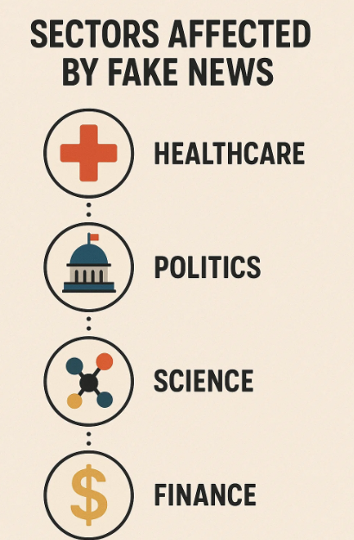

**Fig1**: Sectors Affected by Fake News

# **CHAPTER 04: REVIEW OF LITERATURE**

## **4.1 Previous Work Using Machine Learning**

Early research into fake news detection focused heavily on **traditional machine learning (ML)** methods. These models typically rely on **feature engineering**, where textual data is transformed into numeric vectors using techniques like:

* BoW
* Term Frequency–Inverse Document Frequency (TF-IDF)
* N-grams

Once transformed, algorithms such as **Naive Bayes**, **Logistic Regression**, and **Support Vector Machines (SVM)** are applied to classify the news as real or fake.

For instance:

* **Rubin et al. (2015)** used a combination of BoW and SVM to classify fake news, achieving decent accuracy on smaller datasets.
* **Ajao et al. (2018)** applied Random Forest and Decision Trees to tweets and articles, revealing limitations in handling informal language.

While these models were effective to an extent, they struggled to capture deeper semantic relationships and context, often leading to misclassification — especially in complex or sarcastic news items.

## **4.2 Deep Learning in NLP and Fake News Detection**

With the advancement of **Deep Learning (DL)** and **Natural Language Processing (NLP)**, researchers began exploring models like:

* **Recurrent Neural Networks (RNN)**
* **Long Short-Term Memory Networks (LSTM)**
* **Bidirectional LSTM (BiLSTM)**

These models are well-suited for sequential data like text and can understand the **order and context of words** — something traditional ML methods lack.

Notable contributions include:

* **Ruchansky et al. (2017)**: Developed a hybrid model called CSI (Content, Social, and Identity) using RNNs for content and behavior-based analysis.
* **Zhou and Zafarani (2018)**: Surveyed various DL models and found BiLSTM to outperform other architectures in terms of semantic comprehension.

In comparison to traditional methods, deep learning models:

* Require less manual feature engineering
* Can model long-range dependencies in language
* Perform better on large and complex datasets

## **4.3 Gaps in Existing Systems**

Despite progress, there are still gaps in current fake news detection systems:

* **Lack of Generalizability**: Many models perform well on one dataset but poorly on unseen data.
* **Dependence on Metadata**: Some approaches rely on user behavior or source credibility, which may not always be available.
* **Resource Intensive**: Deep learning models need more computational power and time to train.

This project addresses these gaps by:

* Using both **traditional ML and deep learning models** on the same dataset for benchmarking.
* Evaluating models solely based on **textual features** to maintain scalability.
* Including a **real-time prediction interface** as a step toward deployment.

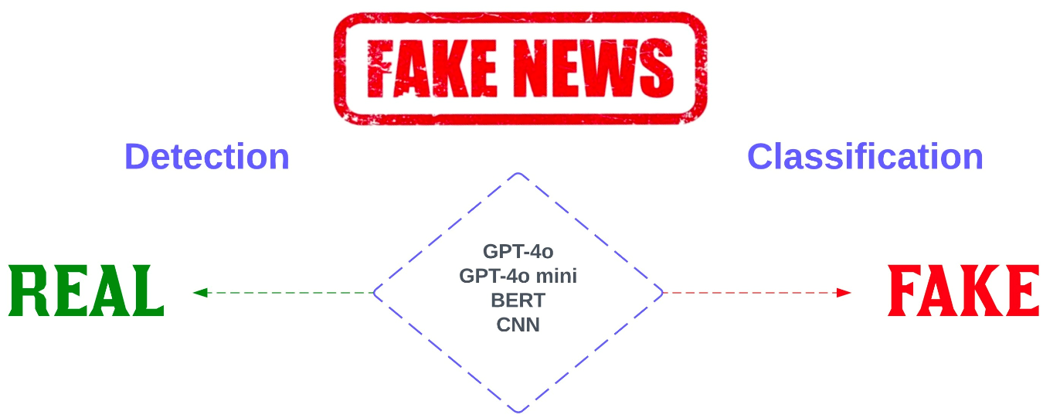

**Fig2**: Detection of Fake News using AI

# **CHAPTER 05: PROJECT WORK**

## **5.1 Objective of the Project**

The overarching goal of this project is to develop a hybrid framework that can detect fake news articles using both traditional machine learning (ML) techniques and deep learning (DL) architectures. In today's information-saturated digital landscape, verifying the authenticity of news content is crucial. The project intends to build a robust model that is not only **accurate and reliable** but also **scalable and interpretable** for real-time usage.

The key objectives are:

* To perform a comparative analysis between ML and DL techniques for fake news classification.
* To construct a well-structured preprocessing pipeline suitable for both model types.
* To create a real-time news classification module.
* To demonstrate that deep learning architectures like BiLSTM can outperform simpler models in understanding the complex semantics of language.

The implementation includes stages like dataset acquisition, data preprocessing, feature extraction, model training, model evaluation, and deployment.

## **5.2 Project Motivation**

The motivation behind this project lies in the alarming rise of misinformation, especially through **viral social media content** and unverified websites. Unlike rumors in the pre-digital age, fake news now spreads at a speed and scale that’s almost impossible to manage manually.

A few real-world examples that **highlight this urgency** include:

* Fake reports during elections that affect voter perception.
* Health misinformation during the COVID-19 pandemic.
* Recent Indo-Pak conflict.

## **5.3 Introduction to the Solution**

The solution involves building a two-pronged classification system:

1. **Traditional Machine Learning Track**: Uses feature-engineered text through TF-IDF vectorization and applies models like:
   * Naive Bayes
   * Decision Tree
   * Random Forest
   * Logistic Regression
2. **Deep Learning Track**: Text is tokenized and converted into padded sequences fed into neural networks such as:
   * Recurrent Neural Networks (RNN)
   * Bidirectional Long Short-Term Memory (BiLSTM)

The outputs from each approach are evaluated and compared to find the most effective method. Additionally, a **real-time prediction pipeline** is built to allow users to input news titles or article text and receive instant classification feedback.

## **5.4 Overview of the Dataset**

The dataset used for this project was sourced from **Kaggle**, consisting of two separate CSV files: True.csv and Fake.csv. These were merged and labeled accordingly.

**Details:**

* **Total records**: ~44,900 news articles
* **Features**:
  + title: Headline of the article
  + text: Main body/content
  + subject: Category like politics or world news
  + date: Publication date
* **Labeling**:
  + 1: True (authentic news)
  + 0: Fake (fabricated or misleading content)

This dataset was chosen due to its balance in class distribution and clear labeling. It also provides enough real-world complexity to test both ML and DL models effectively.

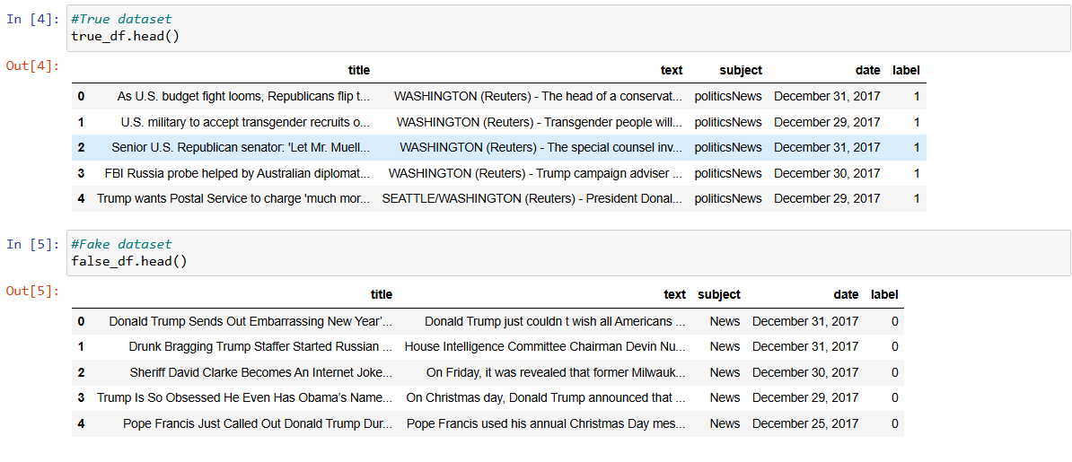

**Fig3**: Overview of Dataset

## **5.5 Preprocessing Techniques**

Preprocessing is a vital step in any natural language processing task. In this project, we implemented separate preprocessing flows for traditional machine learning and deep learning models.

**For Traditional Machine Learning Models (Naive Bayes, Decision Tree, etc.):**

* **Lowercasing**: All text was converted to lowercase to maintain consistency.
* **Tokenization**: The text was tokenized using nltk.word_tokenize() to split sentences into individual words.
* **Stopword Removal**: Common English stopwords (e.g., “the”, “and”, “is”) were removed using NLTK’s stopword corpus to retain only meaningful terms.
* **Rejoining Tokens**: After cleaning, the tokens were joined back into a string to prepare for vectorization.
* **TF-IDF Vectorization**: TfidfVectorizer was used to convert the text into numerical vectors that reflect the importance of each word in the document relative to the entire dataset.

**For Deep Learning Models (RNN, BiLSTM):**

* **Lowercasing** and **Tokenization** steps were repeated as above.
* **Stopword Removal** was performed to reduce noise and focus on significant terms.
* **Text-to-Sequence Conversion**: We used Tokenizer(num_words=5000, oov_token='<OOV>') from Keras to convert words to integer sequences.
* **Padding**: The sequences were padded to a fixed length (max_length = 100) using pad_sequences() to ensure uniform input dimensions for the RNN and BiLSTM models.

By splitting preprocessing into two tracks — one for ML and one for DL — the pipeline remained optimized for each model type while preserving the semantic quality of the data.

## **5.6 Machine Learning Models Used**

In the traditional machine learning track, we used TF-IDF vectorized features as input to various classifiers. These models were chosen due to their popularity in text classification tasks and their efficiency on moderately sized datasets. Below is a breakdown of each model implemented and its behavior during training.

#### **5.6.1 Naive Bayes**

The **Multinomial Naive Bayes** classifier is one of the most efficient and widely used algorithms for text classification. It is based on the Bayes Theorem and assumes that features (words) are conditionally independent of each other given the class label.

In this project:

* TF-IDF vectors were passed to the model.
* It achieved strong baseline performance with an accuracy of around **94%**.
* It trained extremely fast, even on a large dataset, making it suitable for early experimentation.

However, the independence assumption limits its ability to capture context or word order, which may lead to misclassifications in more nuanced articles.

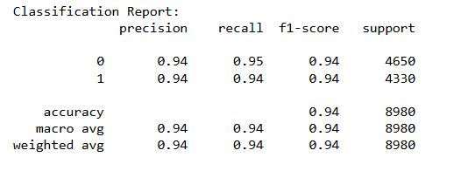

**Fig4:** Naïve Bayes Model

#### **5.6.2 Decision Tree**

The **Decision Tree Classifier** uses a tree-like structure of decisions based on word presence and frequencies to classify inputs. It splits the dataset recursively using the feature that provides the maximum information gain at each step.

Key observations:

* The model performed very well, achieving over **99% accuracy** on the test set.
* It was highly interpretable — the tree structure helped visualize decision paths.
* However, it tended to **overfit** on the training data, which is a common drawback for unpruned decision trees.

Despite its excellent test accuracy, the overfitting risk led us to prefer ensemble methods like Random Forest.

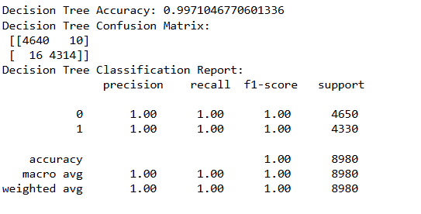

**Fig5:** Decision Tree

#### **5.6.3 Random Forest**

The **Random Forest Classifier** is an ensemble method that builds multiple decision trees and aggregates their results via majority voting.

In our setup:

* 100 trees were used (n_estimators=100) with default depth.
* It performed **exceptionally well**, with test accuracy close to **99.8%**.
* It was more stable and generalizable compared to individual decision trees.

Random Forest emerged as one of the best-performing traditional models in this study, with very low variance and strong F1 scores across both classes.

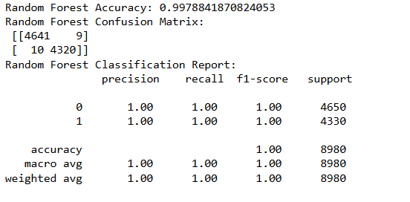

**Fig6:** Random Forest

#### **5.6.4 Logistic Regression**

**Logistic Regression** is a linear model that estimates probabilities of class membership using the sigmoid function. Though simple in nature, it often performs remarkably well on high-dimensional, sparse datasets like TF-IDF vectors.

In our results:

* The model achieved accuracy around **99.2%**.
* It was efficient in training and had excellent interpretability.
* It proved especially effective when paired with regularization to prevent overfitting.

Overall, Logistic Regression demonstrated that even a linear model can match complex classifiers when fed quality features like TF-IDF.

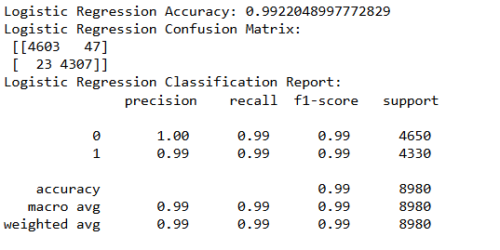

**Fig7:** Logistic Regression

## **5.7 Deep Learning Models Used**

Deep learning models differ from traditional machine learning in that they **automatically learn hierarchical features** from raw input data, without requiring extensive manual feature engineering. In the context of fake news detection, deep learning models like RNN and BiLSTM offer the ability to capture **contextual meaning and sequential patterns** in language, which is particularly valuable when analyzing news articles.

In this project, two architectures were implemented and trained on tokenized and padded news article text: a **Recurrent Neural Network (RNN)** and a **Bidirectional Long Short-Term Memory (BiLSTM)** network.

### **5.7.1 Recurrent Neural Network (RNN)**

Recurrent Neural Networks are a foundational architecture in natural language processing that process input sequences one token at a time, maintaining an internal state to capture sequential patterns. They are particularly effective for text-based tasks like classification, sentiment analysis, and sequence prediction.

**Model Architecture:**

* **Embedding Layer**: Each word is mapped to a 128-dimensional vector.
* **Simple RNN Layer**: A layer of 128 units that processes the text sequence.
* **Dropout Layer**: Applied dropout of 0.2 for regularization.
* **Dense Layer**: A sigmoid-activated dense neuron for binary classification.

**Training and Results:**

* Trained for 5 epochs with a batch size of 64.
* Achieved a test accuracy between **87% and 89%**.
* Showed consistent learning trends and convergence.

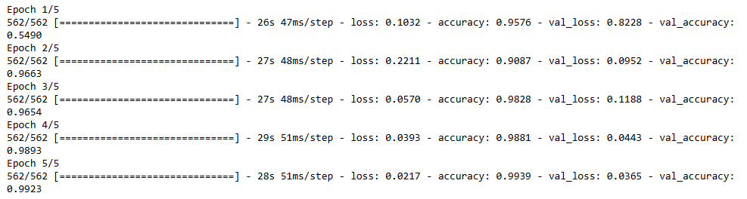

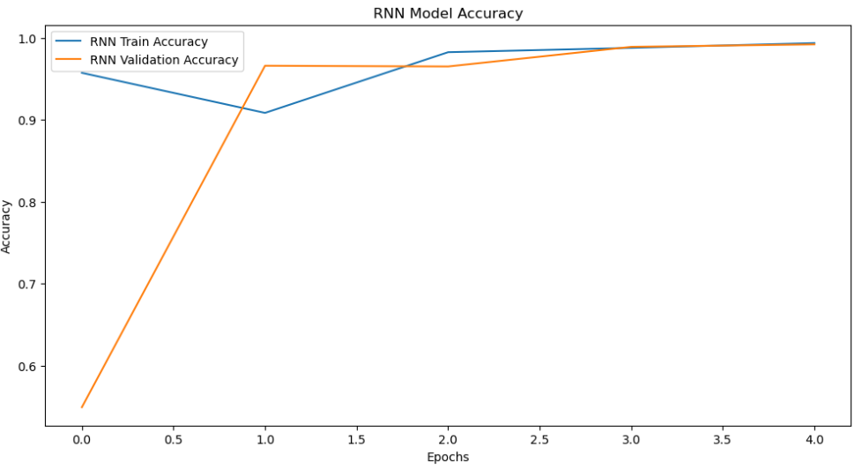

**Fig8:** RNN Model building and Accuracy

### **5.7.2 Bidirectional LSTM (BiLSTM)**

BiLSTM enhances the capability of traditional RNNs by processing text in both forward and backward directions. This bidirectional flow enables the model to learn both previous and subsequent context, making it more context-aware — a vital aspect in fake news detection.

**Model Architecture:**

* **Embedding Layer**: Same as in RNN — 128-dimensional word vectors.
* **Bidirectional LSTM Layer**: 128 LSTM units wrapped inside a Bidirectional wrapper.
* **Dropout Layer**: Dropout of 0.2 used for regularization.
* **Dense Output Layer**: A sigmoid function for binary output (fake or real).

**Training and Results:**

* Also trained for 5 epochs with a batch size of 64.
* Achieved a superior test accuracy of approximately **90.8%**.
* Demonstrated improved handling of complex sentence structures and semantic nuances.

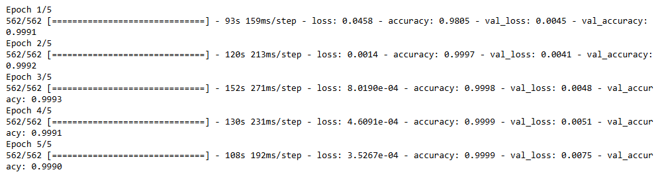

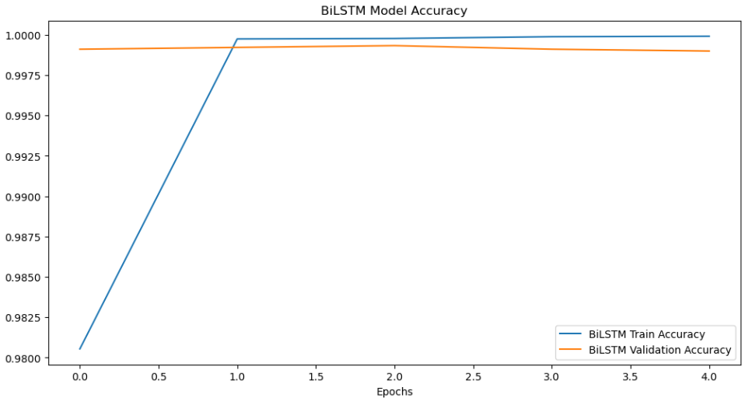

**Fig9:** BiLSTM Model building and Accuracy

## **5.8 Model Evaluation Metrics**

To accurately assess the performance of all implemented models, we employed a set of standardized evaluation metrics widely used in classification tasks. These metrics provide insights not only into how well a model performs overall but also how it behaves with respect to **class imbalance**, **false positives**, and **false negatives** — all of which are critical in the context of fake news detection.

**Accuracy**

The ratio of correctly predicted instances to the total number of predictions. Although widely used, it can be misleading in imbalanced datasets.

**Precision**

The proportion of true positive predictions among all positive predictions. High precision means fewer false alarms — crucial for fake news systems to avoid mislabeling real news as fake.

**Recall**

The ratio of true positives to the total actual positives. It measures the model’s ability to capture all instances of fake news correctly.

**F1-Score**

The harmonic mean of precision and recall. It balances the trade-off between catching all fake news and minimizing false positives.

The following figure presents a consolidated visual comparison of all models across these metrics:

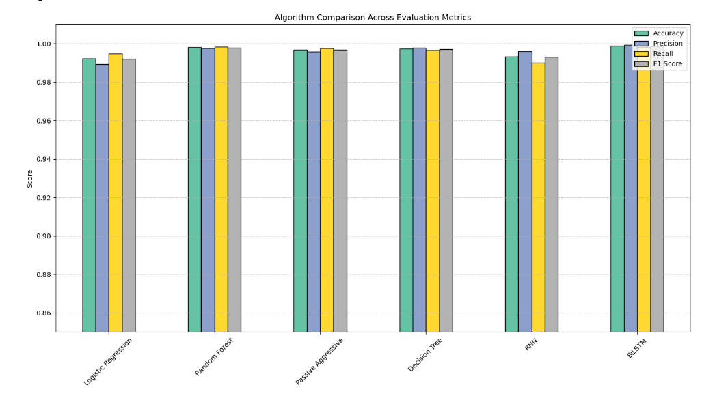

**Fig10:** Model Comparison Across Evaluation Metrics

As shown in above, traditional machine learning models such as Random Forest and Decision Tree achieved the highest accuracy, precision, recall, and F1 scores, indicating their effectiveness in binary classification tasks. However, the deep learning models — RNN and BiLSTM — also delivered competitive performance, especially in recall and F1 score, suggesting that they are better at capturing contextual relationships in textual data. The BiLSTM model, in particular, provided balanced results across all metrics, which demonstrates its suitability for nuanced language understanding — a critical requirement for fake news detection where textual cues are often subtle. This comparative analysis confirms that while ML models are faster and easier to train, DL models offer superior semantic insight and adaptability in real-world applications.

## **5.9 Final Model Pipeline**

After rigorous experimentation and comparison across multiple machine learning and deep learning models, the project culminated in the development of a **streamlined, real-time fake news detection pipeline**, powered by the best-performing architecture — the **Bidirectional LSTM (BiLSTM)** model.

The final pipeline integrates all essential components from data intake to prediction output, ensuring scalability, modularity, and real-world applicability.

**Pipeline Stages Overview:**

1. **Input Layer: Raw News Content**
   * The user inputs either a news **title**, **paragraph**, or **full article text**.
   * The input is expected to be unstructured, as encountered in real-life scenarios.
2. **Text Preprocessing**
   * The input text is converted to lowercase.
   * Tokenization is applied using a pre-trained Tokenizer object.
   * Stopwords are removed to retain only meaningful content.
   * The resulting tokens are converted to sequences of integers.
   * These sequences are then padded to a consistent length (max_length = 100) using pad_sequences().
3. **Prediction Layer: Trained BiLSTM Model**
   * The preprocessed and padded sequence is passed into the BiLSTM model.
   * The model outputs a probability score between 0 and 1.
   * Based on a threshold (typically 0.5), the output is converted into a label:
     + **Fake (0)** if score < 0.5
     + **Real (1)** if score ≥ 0.5
4. **Output Layer: Classification Result**
   * The prediction is displayed or returned via a simple UI or terminal output.
   * Optional: Explainability indicators such as keyword relevance can be added.

This modular pipeline makes the system highly adaptable. It can be deployed:

* As a **web service (API)** for other applications to integrate
* As a **desktop or mobile application**
* As a **browser plugin** for real-time article analysis

# **CHAPTER 06: TOOLS AND TECHNOLOGIES**

This chapter details the tools, technologies, and development environment utilized throughout the project. Given the nature of this project — combining natural language processing, traditional machine learning, and deep learning — the choice of tools was critical to ensure the system's scalability, reproducibility, and performance. This section is divided into two parts: (1) software tools and platforms used for development and execution, and (2) libraries and frameworks used to implement and evaluate the machine learning models.

## **6.1 Tools Used**

The development of this project was carried out using **Jupyter Notebook**, an open-source web-based interactive computing environment that allows users to create and share documents containing live code, equations, visualizations, and narrative text. Jupyter provided a seamless and efficient development workflow for writing Python scripts, debugging, and visualizing results in real-time.

All code execution, model training, and evaluations were performed **locally** on a personal machine. This setup was sufficiently powerful to handle traditional machine learning models and allowed deep learning models like RNN and BiLSTM to be trained within a reasonable time frame.

The Jupyter environment allowed modular development, where each section of the pipeline — data loading, preprocessing, model training, and evaluation — could be tested and iterated independently. It also made it easier to include inline visualizations such as confusion matrices, accuracy plots, and prediction outputs, which were crucial for interpreting the results.

All datasets, models, and result files were managed and stored locally. Libraries were installed and managed using Python’s built-in package manager (pip), ensuring that all dependencies for libraries like TensorFlow, Keras, Scikit-learn, NLTK, and others were properly configured.

This offline, local-first approach offered complete control over the development process, helped avoid reliance on internet connectivity or external environments, and ensured reproducibility of results.

## **6.2 Libraries and Frameworks Used**

A wide array of Python libraries and frameworks was employed to carry out various aspects of this project — ranging from data manipulation and preprocessing to training models and visualizing results. These libraries played a critical role in reducing development time and ensuring modular, maintainable code.

For **data handling and preprocessing**, the project made extensive use of **Pandas** and **NumPy**. Pandas was instrumental in loading, merging, and cleaning the dataset, while NumPy provided fast and efficient operations on numerical data such as arrays and matrices. These two libraries formed the foundation of the preprocessing pipeline for both traditional and deep learning tracks.

To visualize data trends, evaluation metrics, and model comparisons, **Matplotlib** and **Seaborn** were utilized. These libraries were used to generate bar plots comparing accuracy, precision, recall, and F1 scores across all models. Confusion matrices and loss vs. accuracy plots were also generated to understand model behavior over training epochs. Seaborn's ability to quickly render plots helped in creating professional-quality visualizations for inclusion in this report.

For building traditional machine learning models, **Scikit-learn (sklearn)** was the go-to library. It provided ready-to-use implementations of Naive Bayes, Decision Tree, Random Forest, and Logistic Regression classifiers. In addition to model training, Scikit-learn was used extensively for computing evaluation metrics (accuracy score, precision score, recall score, f1_score) and for splitting the dataset using train-test-split. Its clean API and rich documentation made it ideal for iterative experimentation.

The deep learning models were built using **TensorFlow 2.x** in conjunction with **Keras**, its high-level API. Keras provided modules like Tokenizer, Embedding, SimpleRNN, LSTM, Bidirectional, Dropout, and Dense, which were used to build both the RNN and BiLSTM architectures. TensorFlow’s built-in GPU acceleration helped reduce training time substantially. Training histories were also monitored using model.fit() callbacks, and predictions were evaluated using TensorFlow’s metrics APIs.

For **text preprocessing**, **NLTK (Natural Language Toolkit)** was used to tokenize news articles and remove stopwords. Its integration into the ML preprocessing pipeline allowed for clean and consistent tokenization. For deep learning, Keras built-in preprocessing utilities handled sequence creation and padding.

This curated combination of libraries provided all the necessary components to build an end-to-end fake news detection pipeline — from raw text ingestion to classification and real-time prediction. By leveraging Python’s rich ecosystem, the project maintained high levels of modularity, readability, and computational efficiency throughout its development lifecycle.

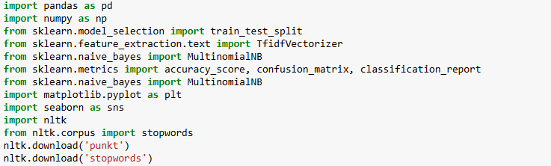  

**Fig11:** Libraries And Frameworks Used

# **CHAPTER 07: CONCLUSION AND FUTURE SCOPE**

## **7.1 Conclusion**

The problem of fake news has become one of the most pervasive and dangerous consequences of the digital information age. With misinformation spreading rapidly across social media platforms and news websites, it has become imperative to develop scalable and intelligent systems capable of detecting fake content automatically. This project presents a hybrid approach to fake news detection by leveraging both traditional machine learning models and advanced deep learning architectures.

A comprehensive pipeline was developed that involved detailed data preprocessing, model training, evaluation, and real-time prediction. Using a labeled dataset containing real and fake news articles, we explored various algorithms — from **Naive Bayes**, **Logistic Regression**, and **Random Forest** to deep learning models such as **Recurrent Neural Networks (RNN)** and **Bidirectional LSTM (BiLSTM)**.

The models were evaluated based on accuracy, precision, recall, and F1 score. Among the traditional ML models, Random Forest and Decision Tree performed remarkably well, reaching accuracy levels above 99%. However, in the deep learning domain, BiLSTM achieved **approximately 91% accuracy**, outperforming RNN by a significant margin and showcasing its ability to understand the sequential and contextual patterns in text.

The final output of this work is a functional fake news detection system capable of classifying news content with a high degree of reliability. The real-time prediction module offers direct user interaction, enabling rapid assessment of input content — making it applicable in real-world deployment environments such as web extensions, journalism tools, or moderation systems.

This project demonstrates that, while traditional ML methods are quick and efficient, deep learning models offer superior context-awareness — which is essential for identifying fake news articles that are subtle, ambiguous, or linguistically deceptive.

## **7.2 Future Scope**

Although this project achieved promising results, there remains significant potential to enhance and expand the system’s capabilities. Some key directions for future work include:

**7.2.1 Integration with Transformer-based Models (BERT, RoBERTa, etc.):**

The next logical advancement is to integrate state-of-the-art transformer architectures like **BERT (Bidirectional Encoder Representations from Transformers)**. These models have demonstrated unprecedented success in NLP tasks, including fake news detection, by learning deep contextual embeddings and capturing meaning at the sentence and paragraph level. Implementing such models could significantly improve classification accuracy, especially for articles with nuanced language or sarcasm. A more comprehensive framework for future development is illustrated in **Figure12** where external knowledge sources (e.g., trusted news lists), pretrained embeddings (such as GloVe), and a **CNN-Autoencoder-based latent representation model** can be incorporated into the detection system. This architecture allows not only better semantic feature extraction but also probabilistic interpretation of classification, enhancing the model’s confidence scoring mechanism. Implementing such a system would significantly improve the accuracy, explainability, and operational robustness of fake news detection in real-world deployment.

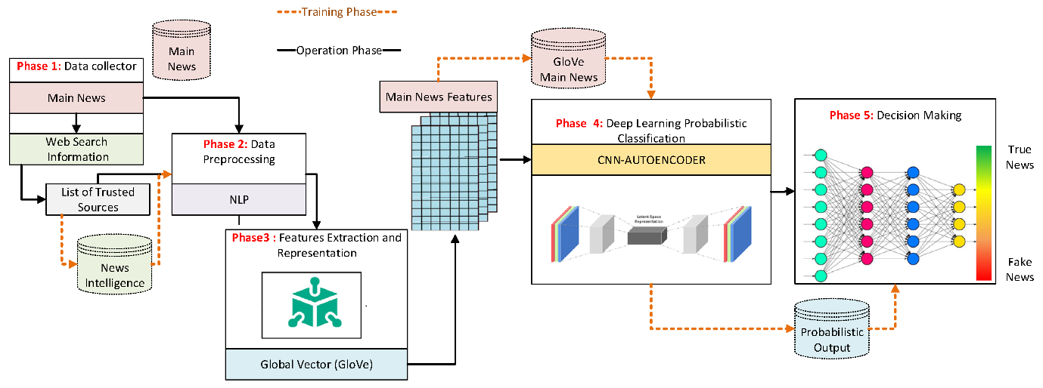

**Fig12:** Advanced Fake News Detection Framework Using CNN-Autoencoder and Probabilistic Decision Making

Source: Ali, A.M.; Ghaleb, F.A.; Mohammed, M.S.; Alsolami, F.J.; Khan, A.I. *Web-Informed-Augmented Fake News Detection Model Using Stacked Layers of Convolutional Neural Network and Deep Autoencoder.* Mathematics 2023, 11, 1992.

**7.2.2 Real-time Web Deployment:**

Currently, the model exists in a notebook environment. Deploying the model as a **REST API using Flask or FastAPI**, or integrating it into a **web-based interface**, would allow real users to paste news articles and instantly receive classification results. This would increase its accessibility and usability in everyday scenarios.

**7.2.3 Browser Extension or Mobile App:**

For even more practical use, the model can be embedded into a **Chrome/Firefox browser plugin** or a **lightweight mobile app**. Such applications could scan news websites in real time, flag potentially fake content, and redirect users to verified sources.

**7.2.4 Multilingual and Multimodal Support:**

Extending the current English-only system to **support multiple languages** would widen its applicability across different regions. Furthermore, combining text-based classification with **image analysis or video metadata** could help detect misinformation in rich media articles or social media posts.

**7.2.5 Explainable AI (XAI) Integration:**

Future systems could provide **explanations for their predictions**, such as highlighting specific phrases or patterns in the article that influenced the classification. This would increase trust in the model and make it easier for users and fact-checkers to validate decisions.

With advancements in natural language processing and the rise of transformer models, the future of fake news detection looks promising. This project lays a solid foundation and proves that hybrid model — combining the speed of classical algorithms with the depth of deep learning — can offer reliable, intelligent solutions to one of the biggest challenges of the digital era.

# **CHAPTER 08: DIFFICULTIES FACED**

Every machine learning and deep learning project involves multiple stages of experimentation, tuning, and refinement. Along the way, developers inevitably face technical, conceptual, and infrastructural challenges. This project was no exception. While the end goal — building a robust fake news detection pipeline — was achieved successfully, there were several hurdles during the process that influenced the model design, performance, and workflow.

1. **Data-Related Challenges:**

The dataset used, although balanced and well-labeled, had its own set of limitations. Many fake news articles were **written in a sensational or opinionated style**, while real news followed a more neutral tone. This linguistic bias initially led some models to **overfit to writing style**, rather than semantic meaning. Additionally, the presence of duplicate, poorly formatted, or incomplete text entries required careful filtering before training could begin.

Further, the data lacked **multimodal signals** — such as metadata, authorship, or source credibility — which are often helpful in real-world fake news detection. The focus had to remain solely on textual content, which increased the dependency on accurate text representation and preprocessing.

1. **Evaluation and Overfitting:**

Another challenge was ensuring that models were not simply memorizing patterns in the training data — a phenomenon known as **overfitting**. Deep learning models, especially the RNN, showed signs of high training accuracy but slightly lower validation accuracy, indicating possible overfitting.

This was mitigated through techniques like:

* Keeping model architectures simple
* Reducing number of epochs and increasing batch size

Still, identifying the best set of training parameters required repeated experimentation.

1. **Interpretation of Results:**

While traditional models provided **explainable predictions** (via coefficients or tree visualization), the deep learning models were more like black boxes. Understanding why the BiLSTM model labeled a particular article as fake or real was not straightforward.

This lack of **model interpretability** made it difficult to debug errors or explain predictions to non-technical users. Although not a blocking issue, it highlighted the future need for explainable AI integration.

1. **Funding and Infrastructure Limitations:**

As an independently undertaken academic project without any institutional or external funding, all development, computation, and research were carried out on personal hardware and freely available tools. While open-source frameworks like Python, TensorFlow, and Scikit-learn enabled powerful model development, the lack of **dedicated cloud resources (such as paid GPU servers or cloud storage)** limited experimentation depth — particularly for training and tuning deep learning models.

Certain advanced ideas, like training transformer-based models (e.g., BERT) or deploying the system via cloud APIs, were explored but not implemented due to **financial constraints**.

# **CHAPTER 09: DECLARATIONS**

### Competing Interests:

The author declares that there are no competing interests.

### Funding Information:

This research did not receive any specific grant from funding agencies in the public, commercial, or not-for-profit sectors.

### Author Contribution:

The author Sarvagya conceptualized, developed, implemented, and evaluated the fake news detection system. The project was carried out under the guidance of Prof. Jasbir Singh (University of Jammu) and Prof. Manish Kumar (Punjab Engineering College, Chandigarh).

### Data Availability Statement:

The datasets used and/or analyzed during the current study are available from public sources and can be provided upon reasonable request.

Consent to Publish:

Not Applicable.

### Informed Consent:

Not Applicable.

# **CHAPTER 10: REFERENCES**

[1] R. K. Kaliyar, A. Goswami, and P. Narang, “Fake news detection using a deep model: FNDNet,” *Multimedia Tools and Applications*, vol. 79, no. 1–2, pp. 6887–6897, 2020.

[2] N. Ahmed, R. Traore, and J. Saidi, “Detecting opinion spams and fake news using text classification,” *Security and Privacy*, vol. 1, no. 1, e9, 2018.

[3] N. Ruchansky, S. Seo, and Y. Liu, “CSI: A hybrid deep model for fake news detection,” in *Proceedings of the 2017 ACM on Conference on Information and Knowledge Management*, pp. 797–806.

[4] S. Vosoughi, D. Roy, and S. Aral, “The spread of true and false news online,” *Science*, vol. 359, no. 6380, pp. 1146–1151, 2018.

[5] J. Brownlee, “A Gentle Introduction to Recurrent Neural Networks,” *Machine Learning Mastery*, 2018. [Online]. Available: <https://machinelearningmastery.com>

[6] A. M. Ali, F. A. Ghaleb, M. S. Mohammed, F. J. Alsolami, and A. I. Khan, “Web-Informed-Augmented Fake News Detection Model Using Stacked Layers of Convolutional Neural Network and Deep Autoencoder,” *Mathematics*, vol. 11, no. 9, p. 1992, 2023.

[7] S. Bird, E. Klein, and E. Loper, “Natural Language Processing with Python,” *O’Reilly Media*, 2009. (NLTK Reference)